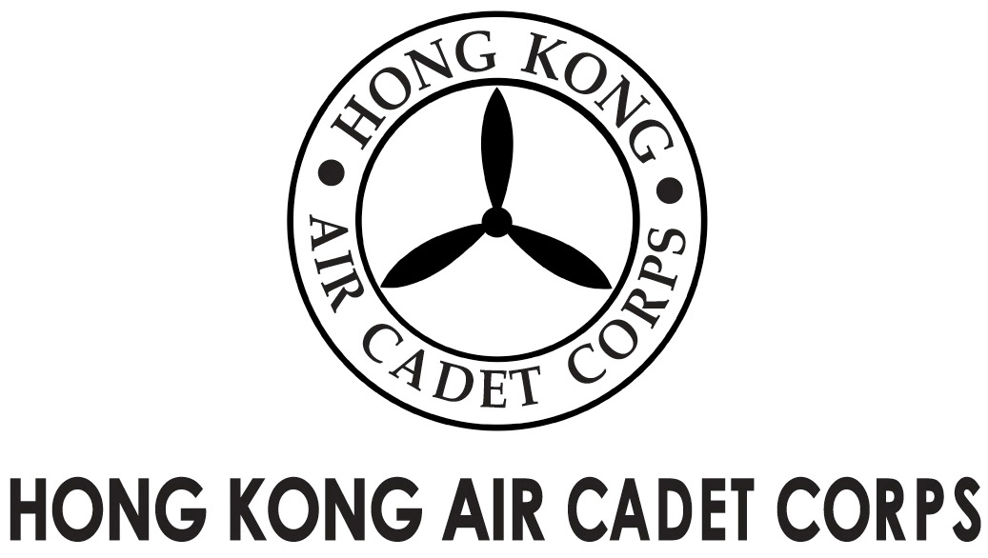

From | Commanding Officer | To | All Members (including EB Members and Honorary Officers)
Our Ref | FD2016/004 | # of Pages | 1
Date | 28 Jan 2016 | Your Ref

HKACC Flag Day 2016 – Gold Flag Donation Scheme

Thank you very much for your support on the Flag Day held on last Saturday. In spite of the historical cold weather, we organized 986 volunteers on the streets of Hong Kong Island raising fund for Corps. Preliminary reports from the bank indicate that we managed to raise about HKD 280,000 from Flag Selling, which still falls short of the target of HKD 350,000 in net revenue (i.e. gross revenue minus project expenses) to qualify the Corps to hold another Flag Day in 2017/18.

I would therefore like to draw your attention to the Gold Flag Donation Scheme, which is still on-going until 22 Feb 2016. All donation received from the Gold Flag Donation Scheme will be counted as income of the Flag Day. A better Flag Day fund raising result is critical for the Corps to petition for permission for future Flag Days.

Please lend your helping hand to raise additional fund for the Flag Day through the Gold Flag Donation Scheme. Enclosed is a Gold Flag Donation Pledge Form and the document detailing the incentive scheme related to the Flag Day. You will be doing the Corps a great favour by completing the donation pledge form and return it to Headquarters by post, fax at 2715 6944 or by email to hq@aircadets.org.hk on or before 22 Feb 2016. Relevant donation could be made by cheques payable to “Hong Kong Air Cadet Corps” or by deposits to HSBC bank account 808-620280-005, in such cases please return the pay-in slips for our records. Receipts for tax deduction purpose will be issued for instances of contribution over HKD 100.

With Warmest Wishes for a Happy Chinese New Year,

LEE Kwok Wing
Gp Capt
Commanding Officer

